March XX, 2022

Hon. Kathy Hochul

Governor, State of New York

Executive Chamber

New York State Capitol

Albany, NY 12224

Dear Governor Hochul:

We write to urge your support of ([A.3172 Fahy](https://www.nysenate.gov/legislation/bills/2021/A3172)) in authorizing an engineering feasibility and planning study for removing a corridor of Interstate 787 (I-787), reconnecting neighborhoods with each other and to the riverfront, and urge the inclusion of $1.5 Million enabling the Department of Transportation to complete this study in the state’s fiscal plan for FY 2022-23. As a diverse coalition of community organizations, local elected officials, and more, reconnecting downtown Albany to the Hudson River waterfront is critical to our area’s future economic growth, the development of our cultural history, and to breaking down barriers for some of our most historically disadvantaged communities.

An engineering feasibility and planning study on reimagining I-787’s portion that runs alongside much of downtown Albany would provide a blueprint for future development and maintenance of the highway itself. This would position the state to receive a portion of [federal transportation dollars](https://www.bloomberg.com/news/articles/2021-02-01/urban-highway-removals-could-get-federal-help?utm_campaign=socialflow-organic&utm_source=twitter&utm_medium=social&utm_content=citylab) for urban highway removal or transformation. Albany should join the growing list of cities in Upstate New York who’ve committed to ambitious projects revitalizing their waterfronts, with Buffalo, Syracuse, Rochester, and more serving as notable examples.

Considerable community support for a reimagined and revitalized Hudson River waterfront has only grown since the [announcement](https://www.wamc.org/post/albany-mayor-kathy-sheehan-delivers-2021-state-city-address) on converting a seldomly-used I-787 exit ramp into a municipal ‘Skyway’ park in Albany. Additionally, the acquisition of the [‘Liberty Park’ parcel](https://www.timesunion.com/news/article/Albany-IDA-approves-taking-rest-of-parking-lot-15897149.php) in downtown Albany adjacent to I-787 reinforces the need to reimagine connection to the Hudson River waterfront and future economic development within that area and beyond.

Given the transformative nature of this project, an engineering feasibility study is a necessary first step in acquiring cost estimates for any future projects. Despite existing and future obstacles, the potential benefit for downtown Albany and across the Capital Region is too great to ignore.

We, the undersigned, respectfully request that you consider the appropriation of funds in this year’s final state budget for FY 2022-23 for an engineering feasibility and planning study to reimagine, remove, and ultimately transform I-787 into a boulevard-style roadway.

Sincerely,

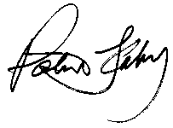

C:\Users\faheyc\AppData\Local\Microsoft\Windows\Temporary Internet Files\Content.Outlook\HJNE5PPQ\breslin signature.jpg

Assemblymember Patricia Fahy State Senator Neil Breslin

109th Assembly District 44th Senate District

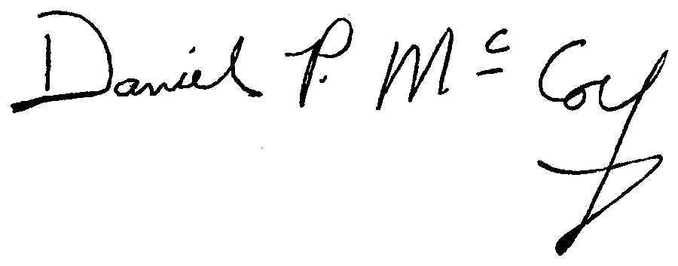



Assemblymember John McDonald Albany County Executive Dan McCoy

108th Assembly District

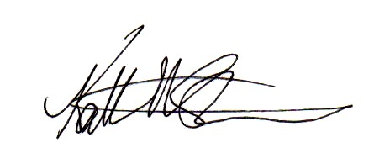



Albany Mayor Kathy Sheehan Albany County Legislature Chair Andrew Joyce

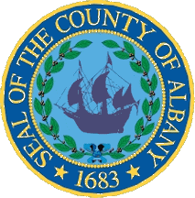

Carolyn McLaughlin Mert Simpson

Albany County Legislator Albany County Legislator



Wanda Willingham Samuel Fein

Albany County Legislator Albany County Legislator

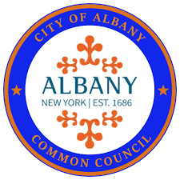

Ray Joyce Joyce Love

Albany County Legislator Albany Common Councilmember



Gabriella Romero Sergio Adams

Albany Common Councilmember Albany Common Councilmember



Kelly Kimbrough Ginnie Farrell

Albany Common Councilmember Albany Common Councilmember



Owusu Anane Deborah Zamer

Albany Common Councilmember Albany Common Councilmember



Alfredo Balarin Meghan Keegan

Albany Common Councilmember Albany Common Councilmember

Albany Riverfront Collaborative NAACP Albany Chapter

Underground Railroad Education Center Walkable Albany



Radix Ecological Sustainability Center Capital District Transportation Authority (CDTA)

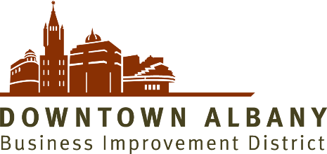

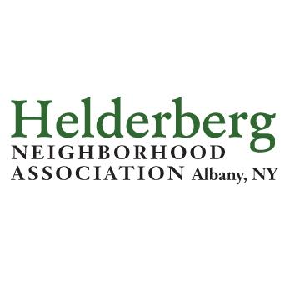

Capitalize Albany Corporation Downtown Albany Business Improvement District

Avillage, Inc. Helderberg Neighborhood Association

Council of Albany Neighborhood Associations (CANA) Pine Hills Neighborhood Association

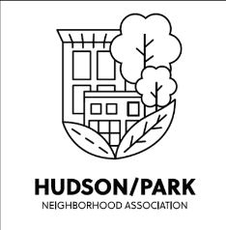

Eagle Hill Neighborhood Association Hudson Park Neighborhood Association

Center Square Neighborhood Association Downtown Neighborhood Association

Manning Boulevard Neighborhood Association Mansion Area Neighborhood Association



North Albany Neighborhood Association Redburn Development Partners



Albany Land Bank Corporation Habitat For Humanity

Historic Albany Foundation (HAF) The Future of Small Cities Institute

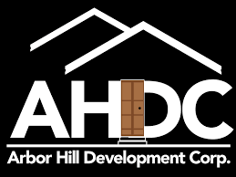

Arbor Hill Development Corporation Upstate New York Black Chamber of Commerce

Capital Region Chamber Business For Good Owner Jahkeen Hoke



TL Metzger & Associates, LLC. Capital District Transportation Committee

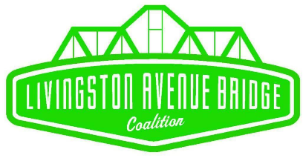

Livingston Avenue Bridge Coalition Center for Law and Justice



Center for Economic Growth (CEG) Yono’s Ristorante Owner Dominick Purnomo

Charles E. Touhey, Carl E. Touhey Foundation Chet Opalka Investment Partners

Rosenblum Companies MRB Group

Around Albany Fort Orange General Store Owner Schuyler Bull



Trinity Health Alliance Shawn Hamlin, Hamlin Design Group



YWCA-GCR LIUNA! Local 190

Greater Capital Region Building & Construction Trades Council

cc: Robert Mujica, New York State Divison of the Budget, Director

Carl Heastie, Speaker of the New York State Assembly

Andrea Stewart-Cousins, Majority Leader of the New York State Senate

Department of Transportation Commissioner Marie Dominguez